I. INTRODUCTION:
Knowledge graphs provide a powerful framework for representing complex relationships between entities, with healthcare being one of the most impactful domains of application. Within this space, medical ontologies serve as structured vocabularies that standardize and precisely express medical concepts and their interrelationships. By offering a unified and interoperable language, they enhance clinical communication, facilitate data sharing, and reduce ambiguity across healthcare systems.
Among such ontologies, the Systematized Nomenclature of Medicine – Clinical Terms (SNOMED CT) is the most comprehensive and widely adopted clinical terminology worldwide. It encompasses more than 350 000 medical concepts connected by over one million relationships, enabling accurate representation of clinical knowledge and interoperability across electronic health records, decision-support tools, and research platforms. Its hierarchical structure allows systematic classification of medical concepts and supports consistent data integration and reasoning. Consequently, SNOMED CT plays a central role in improving patient care, supporting clinical decision-making, and advancing healthcare analytics.
Despite its breadth, SNOMED CT remains incomplete and occasionally inconsistent, particularly in its relational structure. Many medical concepts lack explicit or correctly defined relationships, and certain hierarchical links—especially the is-a relationships, which account for nearly 40 % of all connections—are missing or misclassified. These omissions weaken the ontology’s semantic integrity, leading to potential issues such as misclassification of disorders, incomplete data retrieval, and reduced reliability in clinical analytics. Beyond hierarchical relations, other semantic links—morphological, temporal, or structural—are also underrepresented, limiting the ontology’s expressiveness.
Recent research has explored deep-learning approaches to enrich and validate SNOMED CT. The Static and Dynamic Embedding Approaches (ICHI 2025) treated relation detection as a binary is-a vs. non-is-a task using Embedding Bag for variable-length inputs and transformer encoders (BERT, RoBERTa) for contextual semantics, achieving an F1 ≈ 0.93. The Multi-Relation Classification study (Smart Health 2025) extended this to 133 relation types using TransE knowledge-graph embeddings combined with a multi-head classifier, achieving ≈ 91.96 % test accuracy. Together, these works demonstrated significant progress but revealed two major gaps: fixed embedding sizes may fail to capture nuanced or hierarchical relationships, and scalability remains untested on large, cross-domain clinical data.
Earlier foundational work reflected the same issues. Link Prediction on Complex Networks (2022) showed that most embedding methods rely on a single, static vector space, restricting relational diversity in large graphs. Likewise, node2vec (2016) introduced scalable feature learning but still depended on fixed-dimension embeddings that struggle to scale efficiently on very large networks.
More recent U.S. studies reaffirm these challenges in biomedical settings. The Knowledge Graph Embeddings for ICU Readmission Prediction (BMC Medical Informatics 2023) paper found that increasing embedding dimensions beyond 300 offered no performance gain while increasing computation cost, exposing the limits of fixed-size embeddings. Similarly, the Automated SNOMED CT Concept Annotation using Bi-GRU Neural Networks (AMIA 2025) study used SciBERT’s 768-dimension embeddings and noted that treating all SNOMED CT concepts uniformly reduced semantic coverage and scalability across institutions.
To overcome these limitations, this study integrates SNOMED CT with the MIMIC-IV (Medical Information Mart for Intensive Care IV) dataset—a large-scale electronic health-record (EHR) corpus containing over 400,000 admissions with detailed diagnoses, laboratory results, and clinical notes. While SNOMED CT provides a standardized ontology of medical concepts, MIMIC-IV captures the complexity of real-world patient data. Combining the two offers complementary advantages: SNOMED CT ensures structured semantic representation, serving as the most comprehensive clinical terminology designed to represent clinical concepts consistently and support interoperability across healthcare systems. MIMIC-IV, on the other hand, provides empirical, contextual, and temporal evidence from real clinical practice. It is a large, de-identified database containing records for more than 65,000 ICU patients and over 200,000 emergency-department admissions, organized to highlight data provenance and support a broad range of medical research.
To address these limitations, our work introduces a large-scale, multi-relational clinical knowledge graph that integrates the curated SNOMED CT ontology with empirical diagnostic associations derived from MIMIC-IV, a widely used critical care dataset containing over 40,000 ICU patient admissions. This integration allows us to move beyond purely textual modeling and instead learn relational patterns directly from the underlying biomedical graph structure, enriched with real-world clinical evidence.
However, learning on biomedical graphs of this magnitude introduces fundamental modeling challenges. Traditional graph neural networks (GNNs), including Relational Graph Convolutional Networks (R-GCN), assume a uniform embedding size for all nodes and operate on the full adjacency graph—an approach that is computationally prohibitive for ontologies with hundreds of thousands of nodes. SNOMED CT exhibits an extremely skewed degree distribution, where a small fraction of high-degree nodes (e.g., Disease, Clinical finding) dominate the connectivity structure, while the majority of nodes occur infrequently. Uniform embedding strategies fail to capture this heterogeneity and waste representational capacity on low-impact nodes. Furthermore, full-graph message passing leads to out-of-memory (OOM) failures when applied to graphs exceeding millions of edges.
To overcome these limitations, we propose a Dynamic-Capacity Relational Graph Convolutional Network (R-GCN) tailored for large-scale clinical ontologies and EHR-derived graphs. Our contributions are threefold:
- Dynamic-Capacity Node Embeddings.: We introduce a degree-aware embedding mechanism that allocates larger embedding spaces to high-degree concepts and compact embeddings to low-degree nodes, projecting both into a unified representation space. This design substantially reduces memory consumption while preserving expressiveness for clinically important nodes.
- Safe Node-Centric Subgraph Sampling.: To enable scalable training, we develop a memory-safe subgraph extraction algorithm that expands the local neighborhood around sampled edges while enforcing strict caps on node and edge counts. This allows the R-GCN to learn relational patterns without loading the entire SNOMED CT + MIMIC-IV graph into GPU memory.
- Unified Multi-Relational Clinical Graph Construction.: We construct a heterogeneous graph that combines curated SNOMED CT semantic relations, filtered for active concepts, and empirical co-occurrence relations derived from ICD-10 diagnoses mapped to SNOMED CT via OHDSI Athena. This produces a more comprehensive relational landscape that reflects both the ontology’s intended structure and real-world clinical behavior.
Through this architecture, our model learns to predict missing or weakly defined relations across all SNOMED CT relation types, not just hierarchical ones, and incorporates empirical evidence from ICU patient data to support ontology refinement. Unlike text-only models, our approach directly exploits the topological and multi-relational properties of the ontology, enabling more expressive and semantically grounded representation learning.

II. DATASET:
Two biomedical resources were utilized to construct a unified clinical knowledge graph that integrates ontology:
- SNOMED CT (U.S. Edition 2025-03-01 Snapshot):
- A large-scale clinical terminology containing over 350,000 concepts and more than 3.5 million relationships.
- SNOMED CT provides structured definitions of diseases, findings, and procedures using relationship types such as is_a, part_of, associated_with, and morphology_of.
- MIMIC-IV (Version 3.1):
- An open critical-care database that includes de-identified electronic health records from 40,000+ ICU patients.
Integrating these two resources enables the combination of semantic hierarchy from SNOMED CT with empirical diagnostic co-occurrence patterns from MIMIC-IV, forming the basis for multi-relational graph learning.

SNOMED CT Relation and Description Extraction:
The SNOMED CT release contains two main components essential for semantic graph construction:
- Relationship Table (sct2_Relationship_Snapshot) Each record defines a directed relation between a source concept and destination concept, encoded as {sourceId, typeId, destinationId} with flags for activity status and relationship group.
- Description Table (sct2_Description_Snapshot) Its table provides textual labels for each concept, including fully specified names, preferred terms, and synonyms.

Preprocessing Steps
The dataset was cleaned and standardized using our SNOMED preprocessing script, which performs:
- Filtering to retain only active relationships (active = 1).
- Selecting preferred terms using the identifier typeId = 900000000000013009
- Mapping each relation type ID to a human-readable relation labe (e.g., 116680003 → is_a, 47429007 → associated_with).
- Removing null, incomplete, or corrupted rows.
- Logging before/after counts to ensure reproducibility.
Output:
The final SNOMED relation dataset contains:
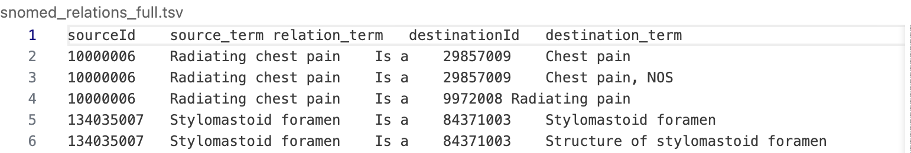
Why This Extraction Was Necessary
- Provided structured semantic relationships for graph construction.
- Ensured readable, interpretable edge labels for downstream analysis.
- Served as the ontology backbone to which empirical relations (from MIMIC-IV) could be later attached.

MIMIC-IV ICD to SNOMED CT Mapping via OHDSI Athena:
- The hosp/diagnoses_icd.csv.gz table was used to extract structured diagnosis information encoded in ICD-9-CM and ICD-10-CM formats.
- For consistency with current SNOMED CT coverage, only ICD-10-CM codes were selected for the study
- The diagnoses in MIMIC-IV are represented using ICD-10 codes, which are optimized for billing and reporting rather than semantic reasoning.
- To align these codes with SNOMED CT’s concept hierarchy, a standardized, curated mapping approach was required.
- I used the OHDSI Athena vocabulary repository, which provides official vocabularies, to perform ICD-10 → SNOMED CT translation.
Reasons for choosing OHDSI Athena:
- Curated “Maps to” relationships: Maintains official ICD↔SNOMED links with clinical equivalence defined by domain experts.
- Regularly updated: Synchronizes with Unified Medical Language System (UMLS) and SNOMED CT releases, avoiding outdated code mappings.
Data Extracted from Athena:
The following two core vocabulary tables were used:
- CONCEPT.csv – defines every concept’s name, ID, vocabulary source (ICD10CM, SNOMED), and domain.
- CONCEPT_RELATIONSHIP.csv – defines relationships between concepts (e.g., Maps to, Maps to value).
Mapping Methodology: The mapping process was:
- Loaded CONCEPT.csv and CONCEPT_RELATIONSHIP.csv.
- Extracted relations labeled: Maps to and Maps to value"
- Filtered for mappings where:
  - Source vocabulary = {ICD10CM}
  - Target vocabulary = SNOMED
- Joined textual concept names for interpretability.
- Merged these mappings with MIMIC diagnosis records.
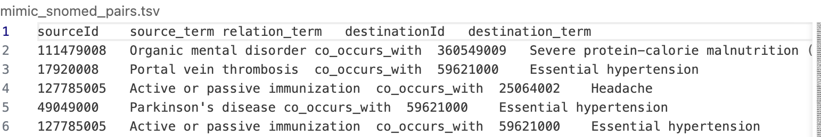
How the Mapping Helped:
- Bridged the semantic gap between administrative ICD coding and ontology-based SNOMED terminology.
- Enabled the transformation of numeric ICD codes into SNOMED CT identifiers that could directly connect with the ontology’s relational network.
- Created a semantically unified schema, allowing MIMIC data to participate in SNOMED’s hierarchical and associative relations.

SNOMED CT and MIMIC-IV Multi-Relational Graph Construction
After both datasets were standardized to SNOMED CT identifiers, a unified multi-relational graph was constructed.
Step 1: MIMIC Co-Occurrence Graph Generation
For each hospital admission (hadm_id), all unique SNOMED-mapped diagnoses were paired to form co-occurrence relations, represented as:
source_term | relation_term | destination_term | relation_term = "co_occurs_with"
Each edge indicates that two diagnoses co-appeared in a patient record.
Step 2: SNOMED Ontology Graph
From SNOMED CT, relationships such as is_a, part_of, associated_with, and morphology_of formed the ontology edges, representing formally curated medical knowledge.
Step 3: Merging Both Graphs
The ontology-based and co-occurrence-based relations were concatenated into a single dataset:
sourceId | source_term | relation_term | destinationId | destination_term | source
where:
- source = SNOMED_CT → denotes curated ontology relations
- source = MIMIC_IV → denotes empirical co-occurrence relations
The final graph, merged_relations.tsv, integrates both ontology-defined and empirical co-occurrence relations, providing a rich, heterogeneous structure suitable for Relational Graph Convolutional Network (RGCN) training.
Sample of Final dataset:
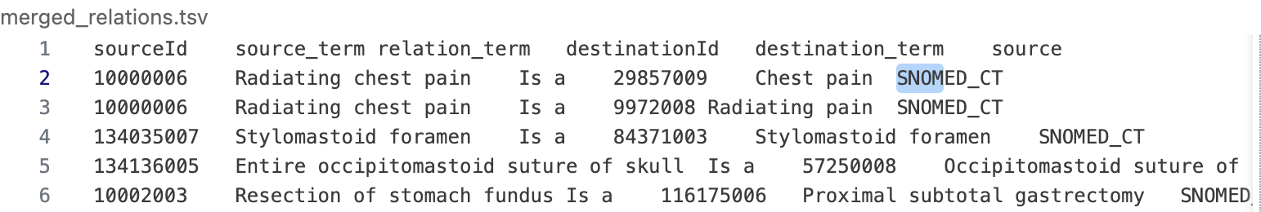
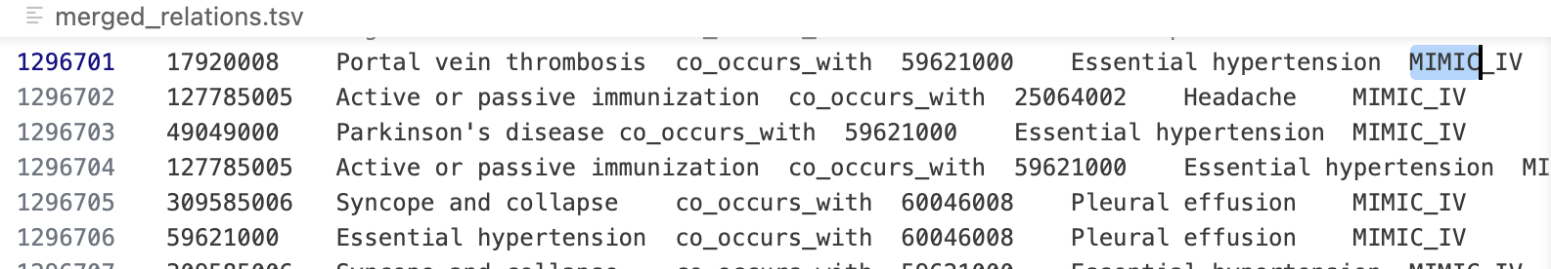

Conflict Detection and Quality Assurance
We detected and resolved inconsistencies in the merged dataset. Conflicting relations were resolved by prioritizing curated SNOMED relations over empirical co-occurrence edges

Identified Conflicts
- Same concept pair linked by different relationship types.
- Multiple ICD-10 codes mapping to the same SNOMED concept.
- Duplicate or redundant edges.
- Missing concept descriptions.

III. GRAPH CONSTRUCTION
To enable large-scale relational learning over the merged SNOMED CT and MIMIC-IV dataset, we transformed the cleaned tabular data into a numerical, multi-relational graph representation suitable for R-GCN training. This section details the full pipeline used to construct the graph tensors, adjacency structures, and training splits.

A. Node and Relation Indexing: The unified dataset produced after dataset cleaning (Section II) contains concept identifiers (sourceId, destinationId) and their associated relationship labels (relation_term). To construct a computable graph, we first convert these symbolic identifiers into integer indices.

1) Node Indexing: All unique concept identifiers appearing as either a source or destination are collected and assigned contiguous integer IDs:
conceptId → node_index ∈ [0, num_nodes).

This mapping ensures that nodes can be stored in PyTorch tensors and queried efficiently during neighbor sampling.

2) Relation Type Indexing: All distinct SNOMED CT semantic relations (e.g., is_a, associated_with, part_of) and MIMIC-IV empirical relations (co_occurs_with) are enumerated and encoded as:
relation_term → relation_id ∈ [0, num_relations).
This enables R-GCN layers to maintain relation-specific transformation matrices.

B. Edge Tensor Construction: After indexing, every row in the cleaned dataset is converted into a directed relational edge of the form: (source_node_index, destination_node_index, relation_id)
These edges are stored in two primary tensors:
- edge_index — a 2 × E tensor, where edge_index[0] = sources, edge_index[1] = destinations.
- edge_type — a length-E tensor assigning each edge its encoded relation ID.
It also computes:
- num_nodes — total number of unique concepts
- num_relations — number of unique relation types
These components form the global adjacency structure used for:
- link prediction evaluation
- negative sampling
- degree computation

C. Train–Validation–Test Split Generation: To support supervised relational learning, partitions edge indices into three mutually exclusive subsets:
- Training edges (~80%)
- Validation edges (~10%)
- Test edges (~10%)
Each split contains integer indices referring to positions within the edge_index tensor:
train_idx, val_idx, test_idx
A fixed random seed ensures full reproducibility across training runs.

D. Node-Centric Adjacency Construction
Although it stores the full graph as tensors, training the R-GCN does not operate on the entire graph at once due to memory constraints. Instead, the model extracts local subgraphs around sampled edges. To support this, constructs a node-centric adjacency structure, where each node stores all outgoing edges along with their relation types:
node_adj[u] = [ (relation_id₁, destination_node₁),
(relation_id₂, destination_node₂),
...]
This data representation is essential for:
- layer-wise neighborhood expansion
- relation-aware neighbor sampling
- enforcing the MAX_EDGES constraint for safe subgraphs
- accelerating lookup times during GAP-2 sampling
Through the combination of node/relation indexing, tensor-based global adjacency, train–test splits, and node-centric adjacency lists, the constructed graph achieves:
- Scalability — supports hundreds of thousands of nodes
- Memory safety — avoids loading full SNOMED CT into GPU memory
- Relation-awareness — maintains distinct transformation matrices for each relation
- Compatibility — integrates seamlessly with degree-aware embeddings and safe subgraph sampling
This graph serves as the structural foundation for the Dynamic-Capacity R-GCN model described.

IV. Model Development
This section presents the relational models evaluated in this study and the proposed scalable Pure Relational Graph Convolutional Network (R-GCN). All models are trained for multi-relational link prediction on large biomedical knowledge graphs constructed from SNOMED CT and an integrated SNOMED–MIMIC dataset.
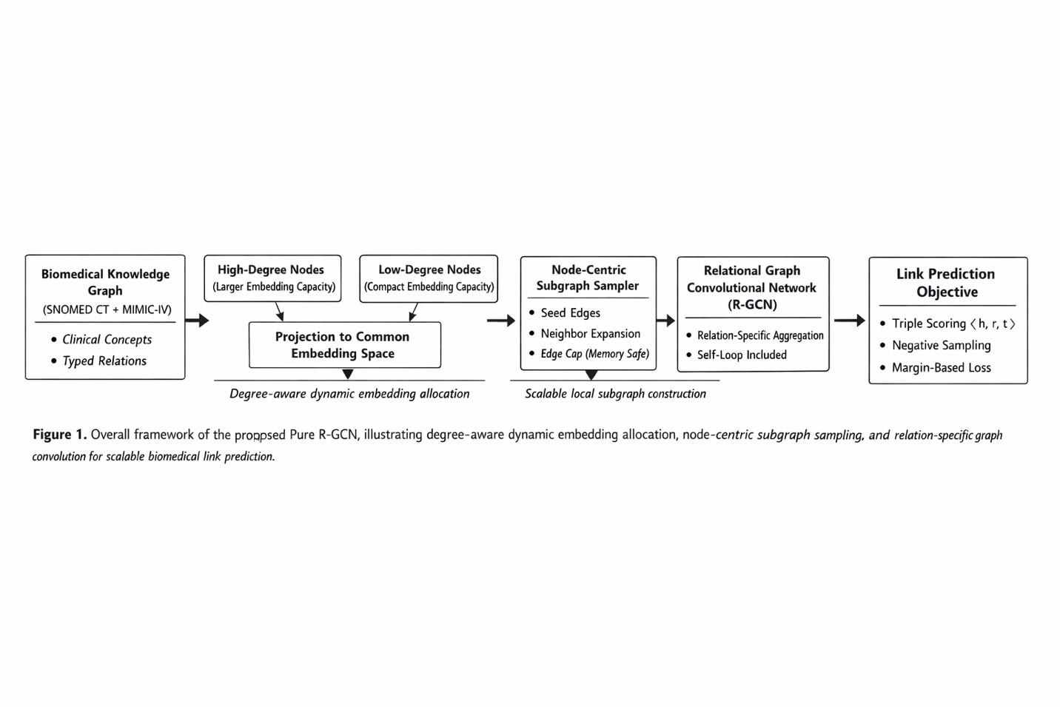

IV-A. ComplEx Baseline
ComplEx is employed as a non-graph baseline for relational learning. Each entity and relation is embedded in a complex-valued vector space, enabling the model to capture asymmetric relations commonly observed in biomedical ontologies.
Given a triple $\left(h , r , t\right)$, ComplEx computes the score:
$$\begin{matrix} & s(h,r,t)=R\left(⟨h,r,\overset{‾}{t}⟩\right), & & \text{(1)}\end{matrix}$$
where $h,r,t∈C^{d}$, $\overset{‾}{t}$denotes complex conjugation, and $R(⋅)$extracts the real part.
ComplEx does not perform neighborhood aggregation or message passing and therefore serves as a fixed-embedding baseline for comparison.

IV-B. Hybrid RoBERTa + R-GCN
To incorporate semantic information from concept descriptions, we evaluate a hybrid model that combines pretrained RoBERTa embeddings with relational graph convolution. Each node is initialized using a fixed textual embedding derived from its SNOMED CT description and is subsequently refined using R-GCN layers.
For node $i$at layer $l$, relational message passing is defined as:
$$\begin{matrix} & h_{i}^{\left(l + 1\right)}=σ\left(\sum_{r∈R}{\sum_{j∈N_{i}^{r}}{\frac{1}{c_{i,r}}}}W_{r}^{\left(l\right)}h_{j}^{\left(l\right)} + W_{0}^{\left(l\right)}h_{i}^{\left(l\right)}\right), & & \text{(2)}\end{matrix}$$
where $N_{i}^{r}$denotes neighbors of node $i$under relation $r$, $W_{r}^{\left(l\right)}$are relation-specific parameters, and $σ(⋅)$is a non-linear activation.
While this hybrid approach improves semantic expressiveness, it incurs high memory overhead and limited scalability, motivating a structure-centric alternative.

IV-C. Pure R-GCN with Dynamic-Capacity Embeddings
To enable scalable relational learning on large biomedical graphs, we propose a Pure R-GCN architecture with dynamic-capacity node embeddings. Nodes are partitioned into high-degree and low-degree groups based on graph degree statistics.
Each node embedding is defined as:
$$\begin{matrix} & e_{i}=\left\{\begin{matrix}P_{h}E_{h}(i), & i∈V_{high} \\ P_{l}E_{l}(i), & i∈V_{low}\end{matrix}\right., & & \text{(3)}\end{matrix}$$
where $E_{h}$and $E_{l}$are learnable embeddings with different dimensionalities and $P_{h}$, $P_{l}$project them into a shared latent space.
These embeddings are then processed using stacked R-GCN layers as defined in Eq. (2), enabling efficient learning while preserving expressive capacity for highly connected clinical concepts.
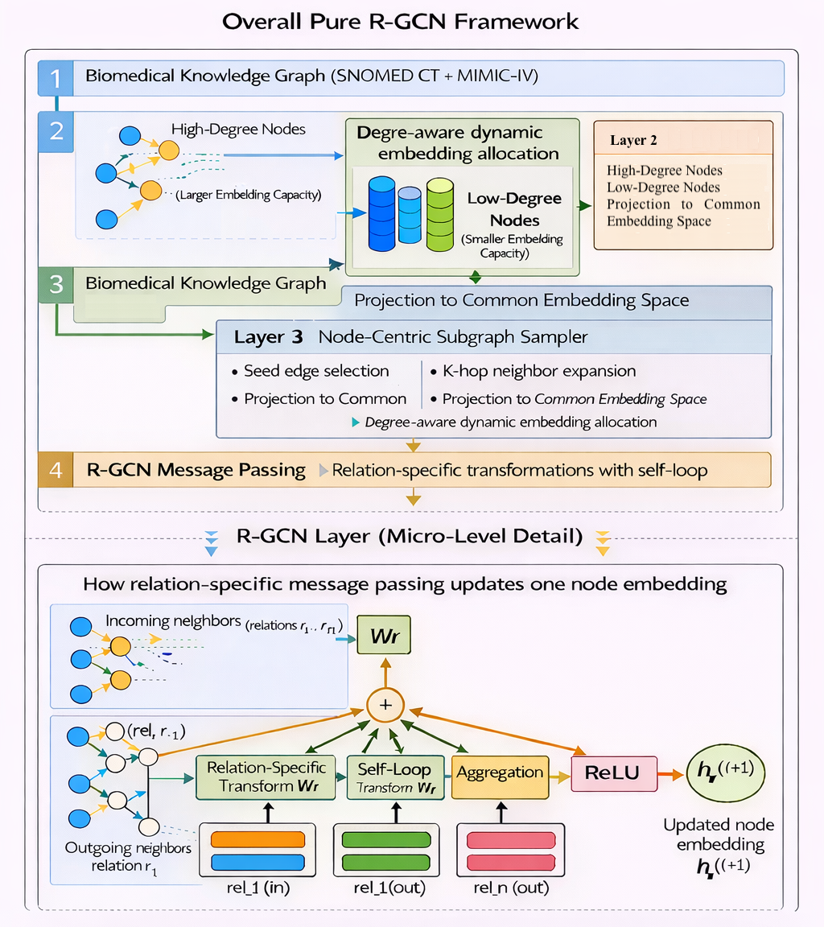

IV-D. Subgraph-Based Training
Due to the scale of the graph, full-graph convolution is infeasible. Training is therefore performed on dynamically sampled node-centric subgraphs. Given a seed set $S_{0}$, neighbors are expanded iteratively as:
$$\begin{matrix} & S_{l+1}=\bigcup_{u∈S_{l}}{{\text{Sample}}_{K}}(N(u)), & & \text{(4)}\end{matrix}$$
where ${\text{Sample}}_{K}(⋅)$selects up to $K$neighbors per node.
Hard constraints on the number of sampled edges ensure memory-safe training while allowing exposure to diverse relational contexts.

IV-E. Triple Scoring Function
All R-GCN variants use a tri-linear scoring function for link prediction:
$$\begin{matrix} & s(h,r,t)=⟨h,r,t⟩=\sum_{k=1}^{d}{h_{k}}⋅r_{k}⋅t_{k}, & & \text{(5)}\end{matrix}$$

where $h$, $r$, and $t$denote the learned embeddings of the head entity, relation, and tail entity.

IV-F. Negative Sampling Strategy

1) Generation of Negative Samples
Biomedical knowledge graphs contain only positive relations; explicit negatives are unavailable. For each observed triple:
$$\begin{matrix} & (h,r,t), & & \text{(6)}\end{matrix}$$
a negative sample is generated by randomly corrupting the tail entity:
$$\begin{matrix} & (h,r,t^{'}),t^{'}∼U(V), & & \text{(7)}\end{matrix}$$
where $t^{'}$is sampled uniformly from the set of nodes and the corrupted triple does not exist in the graph.
This procedure exactly matches our implementation and preserves the relation type, forcing the model to learn entity–relation compatibility.

2) Margin-Based Ranking Loss
Training optimizes a margin-based ranking objective:
$$\begin{matrix} & L=max⁡\left(0, γ-s(h,r,t)+s(h,r,t^{'})\right), & & \text{(8)}\end{matrix}$$
where $γ$is a fixed margin.
Randomized negative sampling introduces stochastic contrastive learning, exposing the model to diverse invalid triples across iterations and improving generalization in incomplete biomedical graphs.

IV-G. Model Variants on the Integrated Graph

Two Pure R-GCN configurations are evaluated on the integrated SNOMED–MIMIC graph, differing in neighborhood size and subgraph capacity. The results indicate that increasing subgraph capacity alters the trade-off between relational context and computational efficiency. In our experiments, the configuration with smaller sampled subgraphs achieves slightly higher-ranking performance, while the larger configuration incurs increased computational overhead without consistent gains across evaluation metrics.

IV-H. Summary
ComplEx provides a fixed-embedding baseline, the hybrid RoBERTa + R-GCN integrates textual semantics at the cost of scalability, and the proposed Pure R-GCN with dynamic-capacity embeddings achieves the best balance between expressiveness, scalability, and performance on large biomedical knowledge graphs.

V. Experimental Setup
This section describes the experimental configuration used to train and evaluate all models. The setup is designed to ensure fair comparison across baselines and proposed models while maintaining scalability on large biomedical knowledge graphs.

V-A. Task Formulation
All models are evaluated on the multi-relational link prediction task. Given a triple
$$(h,r,t),$$
the objective is to learn a scoring function that assigns higher scores to valid triples than to synthetically generated invalid ones.
During evaluation, link prediction is treated as a ranking problem, where the true entity must be ranked above corrupted candidate entities generated via negative sampling.

V-B. Training Procedure
Model training is performed using mini-batch stochastic optimization. For graph-based models, each mini-batch consists of a locally sampled subgraph rather than the full knowledge graph, enabling memory-safe training.
All R-GCN variants are trained using:
- Relation-specific message passing
- Node-centric subgraph sampling
- Margin-based ranking loss
- Random negative sampling
Optimization is carried out using the Adam optimizer with a fixed learning rate of $1×{10}^{-3}$. Training is performed for a fixed number of epochs across all models to ensure comparability.

Hyperparameter | Description
High-degree embedding dimension | Dimensionality assigned to high-degree nodes in R-GCN–based models to capture richer relational structure (512).
Low-degree embedding dimension | Reduced embedding dimensionality for low-degree nodes to improve memory efficiency without sacrificing performance (128).
Common embedding dimension | Shared latent space to which all node embeddings are projected for consistent relational message passing (256).
Hidden dimension | Size of hidden representations within R-GCN layers controlling model capacity (256).
Number of layers | Number of stacked relational graph convolution layers used for neighborhood aggregation.
Dropout rate | Dropout applied between layers to mitigate overfitting during training (0.1 for ComplEx, 0.2 for R-GCN–based models).
Neighbor Sampling(K) | Maximum number of neighbors sampled per node during node-centric subgraph construction (5).
High degree Threshold | Proportion of nodes treated as high degree for dynamic embedding allocation (top 80%).
Subgraph edge cap | Upper bound on the number of edges sampled per subgraph to ensure memory-safe and scalable training (300,000).
Batch Size | Number of positive triples processed per training iteration.
Negative sampling ratio | Ratio of negative to positive triples used during training to learn discriminative link representations (1:1).
Optimizer | Optimization algorithm used to update model parameters during training (Adam).
Learning Rate | Initial step size for the optimizer controlling convergence speed (1 × 10⁻³).
Training Epochs | Total number of passes over the training data (5).

Table I: Hyperparameters used across Models.

V-C. Negative Sampling
Explicit negative relations are not available in biomedical knowledge graphs. Therefore, negative samples are generated synthetically during training.
For each positive triple $\left(h , r , t\right)$, a negative triple is created by randomly corrupting the tail entity:
$$(h,r,t^{'}),t^{'}∼U(V),$$
where $V$denotes the set of all entities. A 1:1 negative-to-positive ratio is used throughout training.
This randomized corruption strategy introduces stochastic contrastive learning, enabling the model to learn discriminative relational representations despite incomplete graph supervision.

V-D. Subgraph Sampling Configuration
Due to the scale of the biomedical graphs, full-graph convolution is infeasible. Instead, training is conducted on node-centric subgraphs constructed dynamically for each batch.
The sampling process expands local neighborhoods around seed nodes using a fixed number of neighbors per hop, subject to a hard cap on the total number of sampled edges. Two configurations are evaluated for the integrated graph to study the impact of subgraph capacity:
- Configuration A: smaller neighborhood size and edge cap
- Configuration B: larger neighborhood size and higher edge cap
This controlled setup allows systematic analysis of the trade-off between computational cost and relational context.

V-E. Evaluation Metrics
Model performance is assessed using ranking-based metrics, which are standard for knowledge graph completion tasks. The following metrics are reported:
- Mean Reciprocal Rank (MRR): evaluates overall ranking quality by measuring the average inverse rank of the correct entity.
- Hits@1: measures exact top-1 prediction accuracy.
- Hits@10: measures whether the correct entity appears within the top 10 predictions.
- ROC–AUC: evaluates score separability between positive and negative triples across all thresholds.
- Precision@K: measures the reliability of the top-K ranked predictions.
Together, these metrics provide a comprehensive evaluation of ranking accuracy and discriminative capability.

V-F. Implementation and Reproducibility
All experiments are implemented in PyTorch and executed on GPU when available. Random seeds are fixed for dataset splitting, negative sampling, and subgraph sampling to ensure reproducibility.
All intermediate outputs, including loss curves, score distributions, ROC curves, and Precision@K plots, are saved for post-hoc analysis and result verification.

VI. Results and Discussion
This section presents the experimental results of all evaluated models and provides an analysis of their performance on large-scale biomedical knowledge graphs. The results highlight the effectiveness of the proposed Pure R-GCN architecture and the impact of integrating empirical clinical relations.

VI-A. Quantitative Results

Model | MRR | Hits@1 | Hits@10
ComplEx | 0.2006 | 0.1575 | 0.2675
Hybrid RoBERTa + R-GCN | 0.3799 | 0.1900 | 0.8200
R-GCN(SNOMED CT) | 0.7593 | 0.6285 | 0.9970
R-GCN(Integrated) | 0.8531 | 0.7546 | 0.9970
Table II: Link prediction performance comparison across evaluated models
The embedding-based ComplEx model achieves the lowest performance across all metrics, reflecting its inability to leverage graph structure beyond fixed embeddings. The Hybrid RoBERTa + R-GCN model improves ranking performance by incorporating textual semantics; however, gains are primarily observed in Hits@10 rather than top-ranked accuracy.
The Pure R-GCN trained on the SNOMED-only graph significantly outperforms both baselines, demonstrating the benefit of relation-aware message passing and degree-aware embeddings. The best performance is achieved by the Pure R-GCN trained on the integrated SNOMED–MIMIC graph, which consistently yields the highest MRR, Hits@1, and ROC–AUC scores.
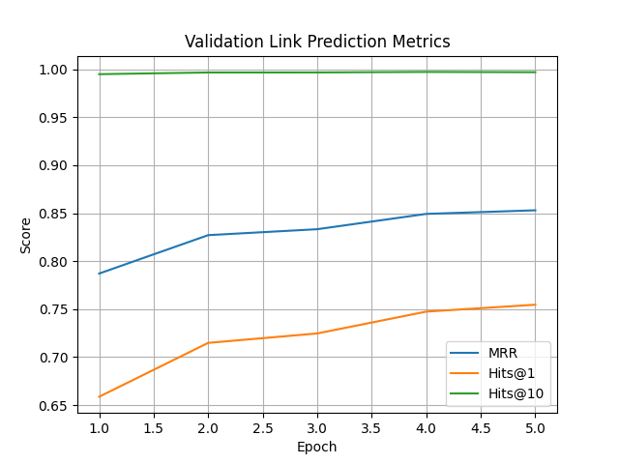
Figure 3. Validation ranking performance of the R-GCN across training epochs,
measured using MRR, Hits@1, and Hits@10.

VI-B. Comparison of Pure R-GCN Variants

R-GCN Variants | Neighbor(K) | Edge Cap | Batch Size | MRR | Hits@1 | Hits@10
Config A | 5 | 300k | 2048 | 0.8531 | 0.7546 | 0.9970
Config B | 10 | 600k | 4096 | 0.8234 | 0.7178 | 0.9919
Table III: Sensitivity analysis of the proposed Pure R-GCN under different subgraph sampling and batch configurations.
Increasing neighborhood size and edge cap alters the trade-off between contextual capacity and computational efficiency, with performance remaining competitive across configurations. This indicates that increased relational context enables the model to capture more informative multi-hop dependencies. However, this improvement comes at the cost of higher computational overhead, highlighting a trade-off between efficiency and representational capacity.

VI-C. Analysis of Ranking and Discrimination Performance
Across all Pure R-GCN variants, ROC–AUC values remain consistently high, indicating strong separability between positive and negative triples. This confirms that the learned scoring function effectively distinguishes valid biomedical relations from corrupted ones.
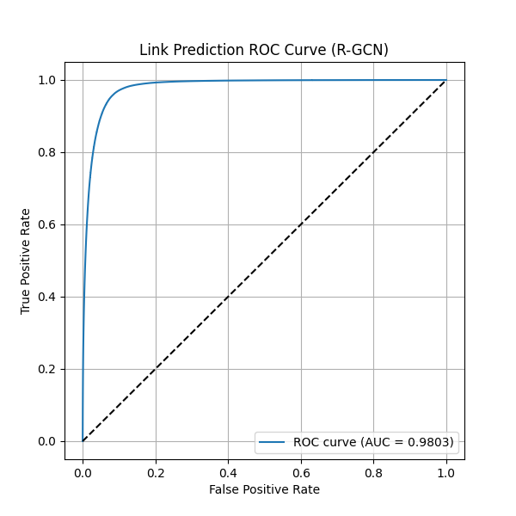
Figure 4. Receiver operating characteristic (ROC) curve for link prediction using the R-GCN, demonstrating strong discrimination between positive and negative triples
Precision@K results further show that top-ranked predictions are reliable, particularly for small values of $K$. This is crucial in biomedical applications, where only a limited number of candidate relations are typically reviewed by domain experts.
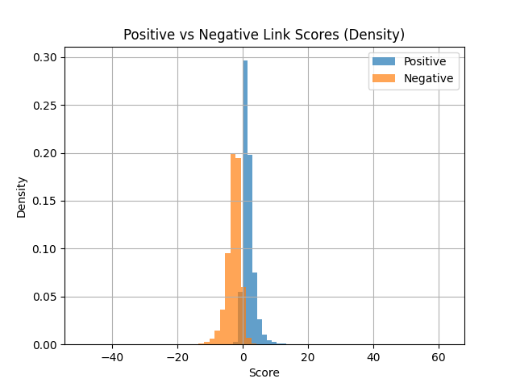
Figure 5. Distribution of learned scores for positive and negative triples, illustrating clear separation induced by the margin-based ranking objective

VI-D. Impact of Graph Integration
Integrating MIMIC-derived co-occurrence relations with the SNOMED CT ontology leads to a clear performance improvement. The empirical clinical edges introduce complementary relational signals that are not explicitly encoded in the ontology, enabling the model to learn clinically meaningful associations.
These results demonstrate that combining curated biomedical knowledge with real-world clinical data enhances relational learning and improves link prediction accuracy.

VI-E. Discussion
The experimental results validate the design choices of the proposed Pure R-GCN architecture. Dynamic-capacity embeddings allow efficient allocation of representational power based on node connectivity, while node-centric subgraph sampling enables scalable training on large graphs.
Compared to text-enhanced models, the Pure R-GCN achieves superior performance without reliance on pretrained language models, making it more scalable and interpretable for large biomedical knowledge graphs.

VII. Conclusion and Future Work
In this work, we presented a scalable relational learning framework for large biomedical knowledge graphs based on a Pure Relational Graph Convolutional Network (R-GCN). The proposed approach addresses key limitations of existing methods by introducing degree-aware dynamic-capacity embeddings and node-centric subgraph sampling, enabling memory-safe training on graphs containing hundreds of thousands of nodes and millions of relations.
Extensive experiments on SNOMED CT and an integrated SNOMED–MIMIC dataset demonstrate that the proposed Pure R-GCN consistently outperforms embedding-based baselines and text-enhanced graph models across all ranking-based evaluation metrics. The results confirm that structure-centric relational learning with relation-specific message passing can effectively capture complex biomedical semantics without reliance on pretrained language models. Moreover, integrating empirical clinical co-occurrence relations with curated ontology knowledge yields further performance gains, highlighting the complementary nature of real-world clinical data and biomedical ontologies.
Despite these promising results, several directions remain for future research. While randomized negative sampling provides an effective approximation of invalid relations, incorporating harder or adaptive negative sampling strategies may further improve discrimination between closely related clinical concepts. Additionally, the current framework assumes a static graph structure; extending the model to incorporate temporal or longitudinal relations would enable modeling of disease progression and evolving patient states. The model also operates in a transductive setting, and future work may explore inductive extensions capable of generalizing to unseen concepts or relations. Finally, clinical validation and interpretability analyses involving domain experts are necessary to assess the practical applicability and trustworthiness of the predicted relations.
Overall, this study demonstrates that scalable, structure-centric graph neural networks provide a robust and flexible foundation for biomedical knowledge graph completion, offering a strong basis for future research at the intersection of clinical data integration and relational machine learning.

References:
node2vec: Scalable Feature Learning for Networks
https://arxiv.org/pdf/1607.00653
Link Prediction on Complex Networks: An Experimental Survey
https://link.springer.com/article/10.1007/s41019-022-00188-2
Knowledge Graph Embeddings for ICU Readmission Prediction – BMC Med. Inform. & Decis. Making (2023)
https://pubmed.ncbi.nlm.nih.gov/36658526/
Automated SNOMED CT Concept Annotation in Clinical Text Using Bi-GRU Neural Networks
https://arxiv.org/abs/2508.02556

